World History NAME: _____________________________________________
Coal Mining and the Industrial Revolution

Instructions: Fill out the following chart with information from Morgan Spurlock’s 30 Days - Coalmining and from the reading.
 | Industrial Revolution  from attached article | Today  from 30 Days video in class
Why was coal mining necessary/what was coal used for?
Who were the miners?
Benefits of mining as a career
Risks of mining as a career
What methods were used to mine coal?
What methods were used to prevent explosions?
What changes took place in the mining industry during this time period?
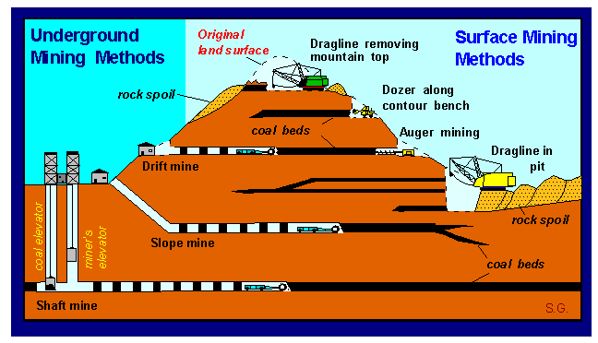
Coal Mines in the Industrial Revolution
Coal was needed in vast quantities for the Industrial Revolution. For centuries, people in Britain had made do with charcoal if they needed a cheap and easy to acquire fuel. What ‘industry’ that existed before 1700, did use coal but it came from coal mines that were near to the surface and the coal was relatively easy to get to. The Industrial Revolution changed all of this.
Before the Industrial Revolution, two types of mines existed: drift mines and bell pits. Both were small scale coal mines and the coal which came from these type of pits was used locally in homes and local industry.
University Of Kentucky. "Methods of Mining." Kentucky Geological Survey. University Of Kentucky, 26 Feb. 2006. Web. 17 Apr. 2012. <http://www.uky.edu/KGS/coal/coal_mining.htm>.

However, as the country started to industrialize, more and more coal was needed to fuel steam engines and furnaces. The development of factories by Richard Arkwright (powered by the steam engine) and the improvement of the steam engine by James Watt (fueled by coal) further increased demand for coal. As a result coal mines got deeper and deeper and coal mining became more and more dangerous.
Coal shafts could go hundreds of feet into the ground. Once a coal seam was found, the miners dug horizontally. However, underground the miners faced very real and great dangers.
Even with Watt's improved steam engine, flooding was a real problem and mine explosive gas (called fire damp) would be found the deeper the miners got. One spark from a digging miner’s pick axe or candle could be disastrous. Poison gas was also found underground. Pit collapses were common—the sheer weight of the ground above a worked coal seam was colossal and mines were only held up by wooden beams called props.
Regardless of all these dangers, there was a huge increase in the production of coal in Britain. Because coal was so difficult and expensive to move, towns and other industries grew up around the coal mining areas so that the workers came to the coal regions. This in itself created problems as these towns grew without any obvious planning or thought given to the facilities the miners and their families would need.
The increase in coal production:
1700 : 2.7 million tons
1750 : 4.7 million tons
1800 : 10 million tons
1850 : 50 million tons
1900 : 250 million tons

How did the miners try to overcome the dangers they faced?
To clear mines of gas - be it explosive or poisonous - a crude system of ventilation was used. To assist this, young children called trappers would sit underground opening and shutting trap doors which went across a mine. This allowed coal trucks through but it also created a draught and it could shift a cloud of gas. However, it was not effective. It was also believed that a system of trap doors might help to stop the blast of an explosion damaging more of the coal mine. It was not until 1807 that the problem was eased when John Buddle invented an air pump to be used in mines. Flooding was a risk that was out of the control of the miners as even Watts steam engines could not cope if a mine had a serious flood. Likewise, pit props could only take a certain amount of strain. The risk of explosion was reduced by the invention by Sir Humphrey Davy of a safety lamp in 1815 which meant that a miner could have light underground but without having to use the exposed flame of a candle. The lamp became known as the "Miners Friend". It gave off light but a wire gauze acted as a barrier between the heat given off and any gas it might have had contact with.

Regardless of these developments, mining remained very dangerous. A report on deaths in coal mines to Parliament gave a list of ways miners could be killed:
- falling down a mine shaft on the way down to the coal face
- falling out of the ‘bucket’ bringing you up after a shift being hit by a fall of dug coal
- falling down a mine shaft as it was lifted up
- drowning in the mine crushed to death killed by explosions
- suffocation by poisonous gas
- being run over by a tram carrying dug coal in the mine itself
- explosion in the mine
- being trapped in a collapsed mine

In one unnamed coal mine, 58 deaths out of a total of 349 deaths in one year involved children thirteen years or younger. Life for all those who worked underground was very hard.
In 1842, Parliament published a report about the state of coal mining - the Mines Report - and its contents shocked the nation. The report informed the public that children under five years of age worked underground as trappers for 12 hours a day and for 2 pennies a day; older girls carried baskets of dug coal which were far too heavy for them and caused deformities in these girls.
One girl - Ellison Jack, aged 11 - claimed to the Commission of Enquiry that she had to do twenty journeys a shift pushing a tub which weighed over 200 kilos and if she showed signs of slacking, she would be whipped. Children had to work in water that came up to their thighs while underground; heavily pregnant women worked underground as they needed the money. On unnamed woman claimed that she gave birth on one day and was expected by the mine manager to be back at work that very same day! Such was the need to work - there was no social security at this time - she did as the manager demanded.
Trueman, Chris. "Coal Mines in the Industrial Revolution." History Learning Site. HistoryLearningSite.co.uk, 2012. Web. 17 Apr. 2012. <http://www.historylearningsite.co.uk/coal_mines_industrial_revolution.htm>.

QUESTION:

Do the mine workers have a choice to work in the mine? Why or why not? Support your answer with evidence from the video and from the article.

