Classical Greece Name Hour
Pages: 101, 121, 124, 132, 137, & 144

1. LABEL the following bodies of water on maps on front and back:
Aegean Sea Ionian Sea Mediterranean Sea Gulf of Corinth
Black Sea

2. COLOR the Greek homeland on the maps on front and back in GREEN (p. 121).
(Be sure to include all outlying islands)

3. Define city-state:_

4. LABEL the following city-states:
1) Thebes | 3) Mycenae | 5) Sparta | 7)Athens
2) Olympia | 4) Corinth | 6) Delphi | 8) Knossus
(*Mycenae was settled by the Mycenaeans around 2000 B.C. and was the supposed home of Agamemnon who led the Greeks in battle against the Trojans in the Trojan wars)

5. LABEL the city of TROY in RED:

6. Why were the TROJAN WARS fought (p. 125)?

7. Using an ORANGE star (*) label the following battle sites:
Thermopylae Marathon Salamis
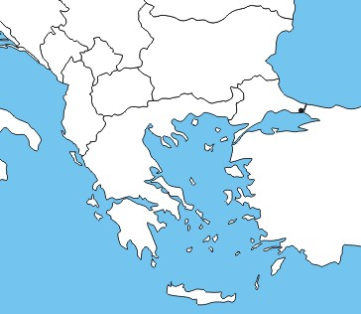
8. LABEL the area known as Peloponnesus (no color needed)

9. Who fought in the Peloponnesian War (p. 137)? -Who won the war?

11-14 are on the back side

