AP Human Geography
Please follow the instructions to below. Use your textbook and the Atlas to answer the following questions.
For each Map follow the directions below:
- Label the four maps one of the five major religions (Hindu and Judaism will be on the same map)
- Identify hearth of each of the major religions (C-Christianity, I-Islam, B-Buddhism, H-Hindu/J-Judaism)
- Identify and label the diffusion of each religion on the map (use arrows from the hearth).
- Use the map on page 182 to shade in the distribution of four major religions (label Judaism do not shade)
Universalizing Religions-
Answer the following question on a separate sheet of paper.
- Identify 3 major divisions/branches of Christianity and Islam.
- Identify and explain the historical events that created the divisions of Christianity.
- Identify and explain the historical events that created the divisions of Islam.
- Identify and explain the diffusion of Catholicism/Protestantism.
- Identify and explain the diffusion of Islam.
- Identify the key person for the diffusion of Buddhism, Islam and Christianity.
- How is the diffusion of Buddhism different from Christianity and Islam?
Ethnic Religions
Answer the following question on a separate sheet of paper.
- Explain the type of diffusion for Hinduism and Judaism.
- Explain the smaller densities of both these religions compared to the 3 Universalizing religions.
- Explain differences of concentration of Hinduism and Judaism.
Sacred Sites/Sacred Places
Match up the Sacred Site/Place with the religions above.
- Jerusalem
- Mecca
- Vatican
- Ganges River
- Bodhi Tree
- Explain the differences in Sacred Site/Places for Universalizing Religions compared to Ethnic Religions.
For each of the Religions identify the location with the highest density of followers (Country or Region)
Islam (Country)-
Buddhism (Region)-
Roman Catholic (Region)-
Judaism (Country)-
Orthodox (Region)-
Hinduism (Country)-
Protestant (Region)-

Religious Structures
Match the Religious structure with one of the major religions from above. Locations of Religions
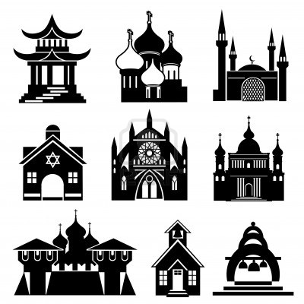

Other Religions/Questions-
Answer the question below.
- What group of religions is the most widely distributed religion other than the big 5?
- What are the main characteristics of Taoism, Confucianism and Shintoism?
- Explain the effect that rising secularism may have on the cultural landscape of the World.
- Identify and explain the religious fundamentalism/Extremist for each group below.
Christianity-
Judaism-
Islam-

