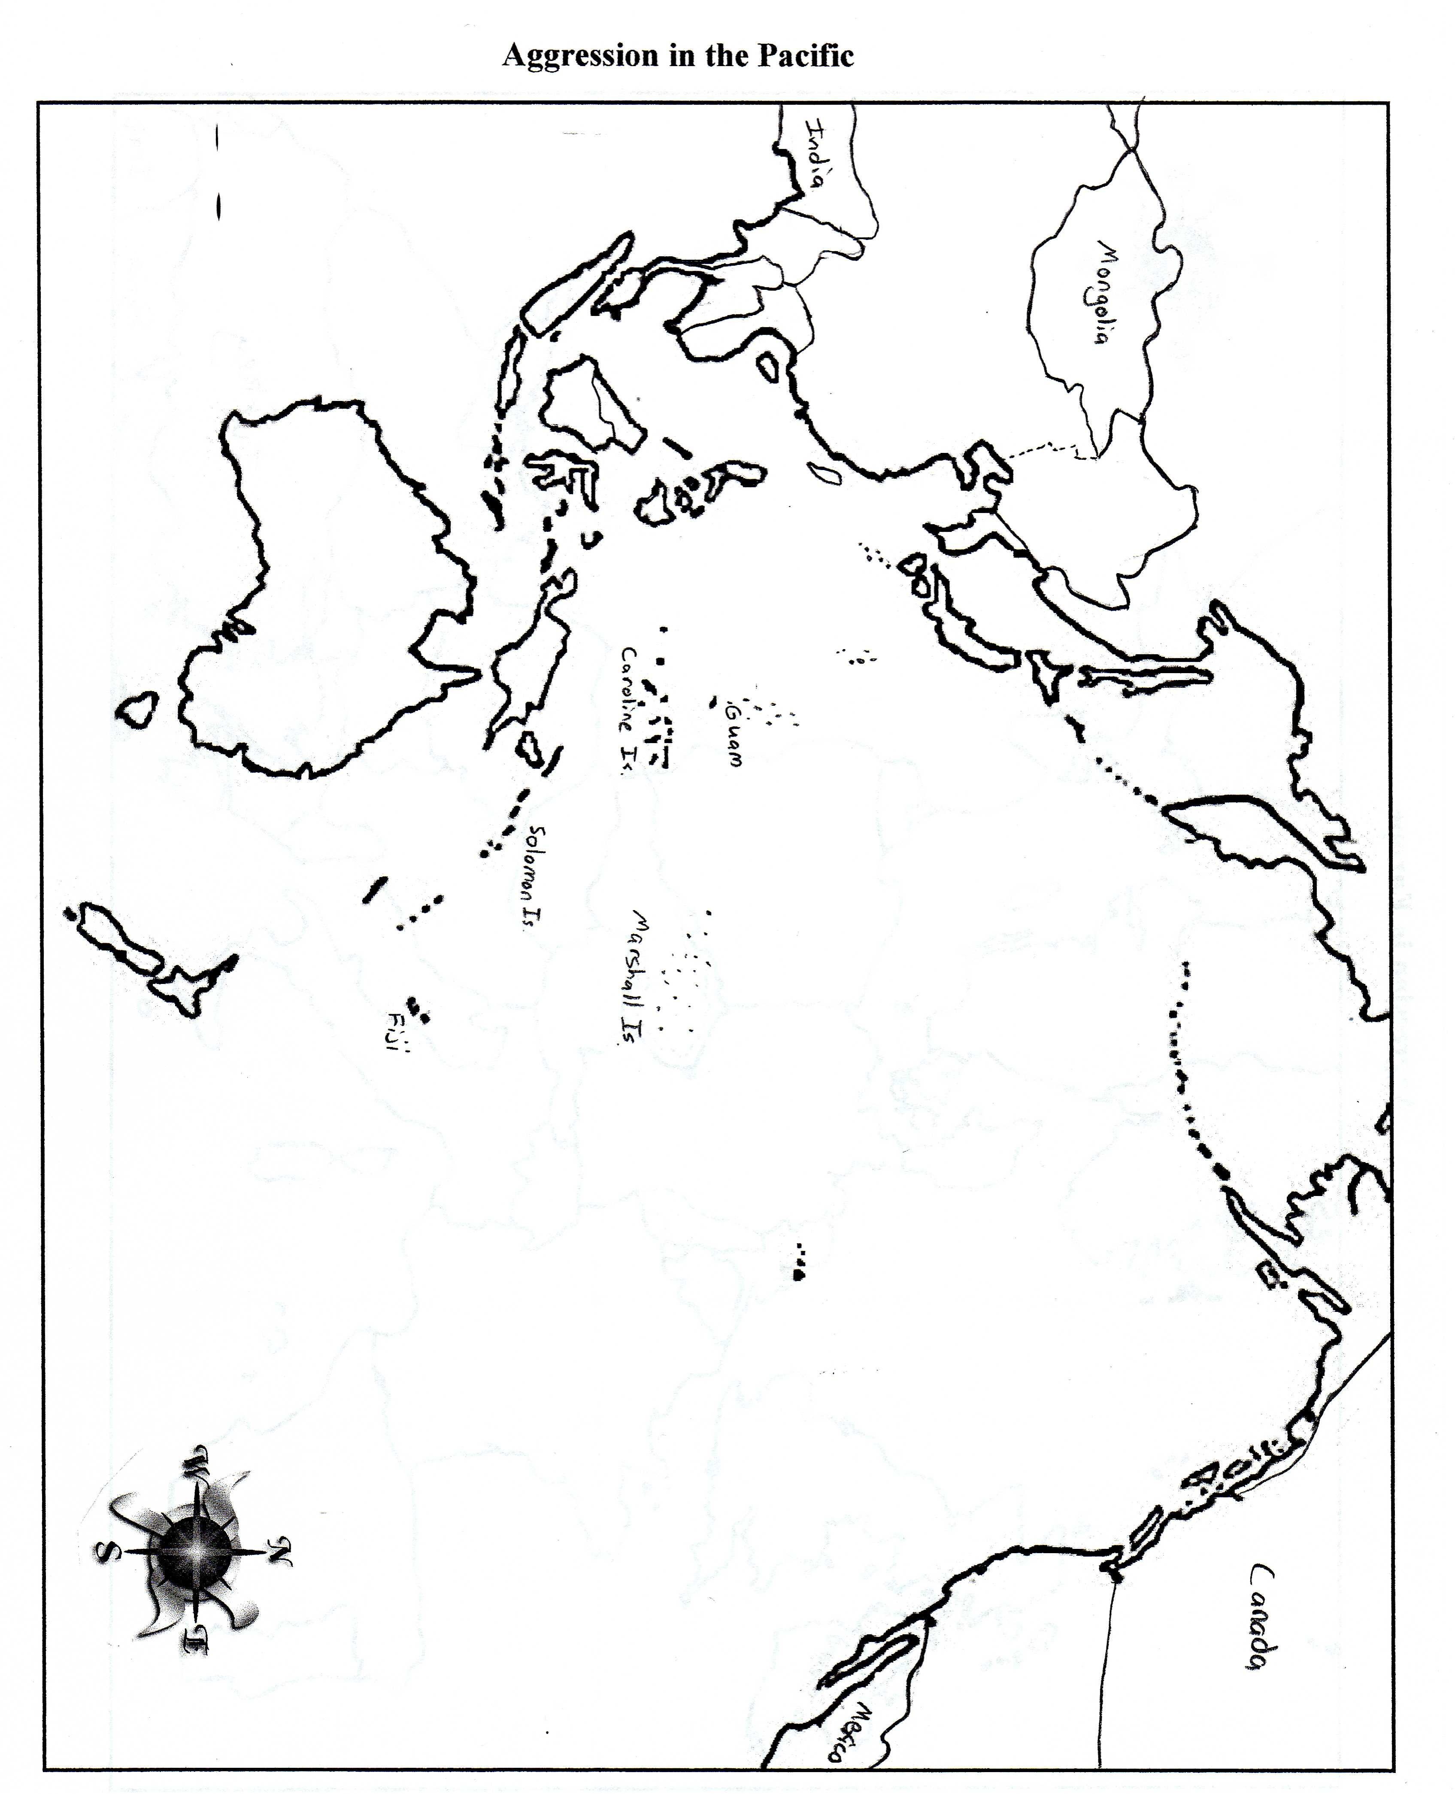

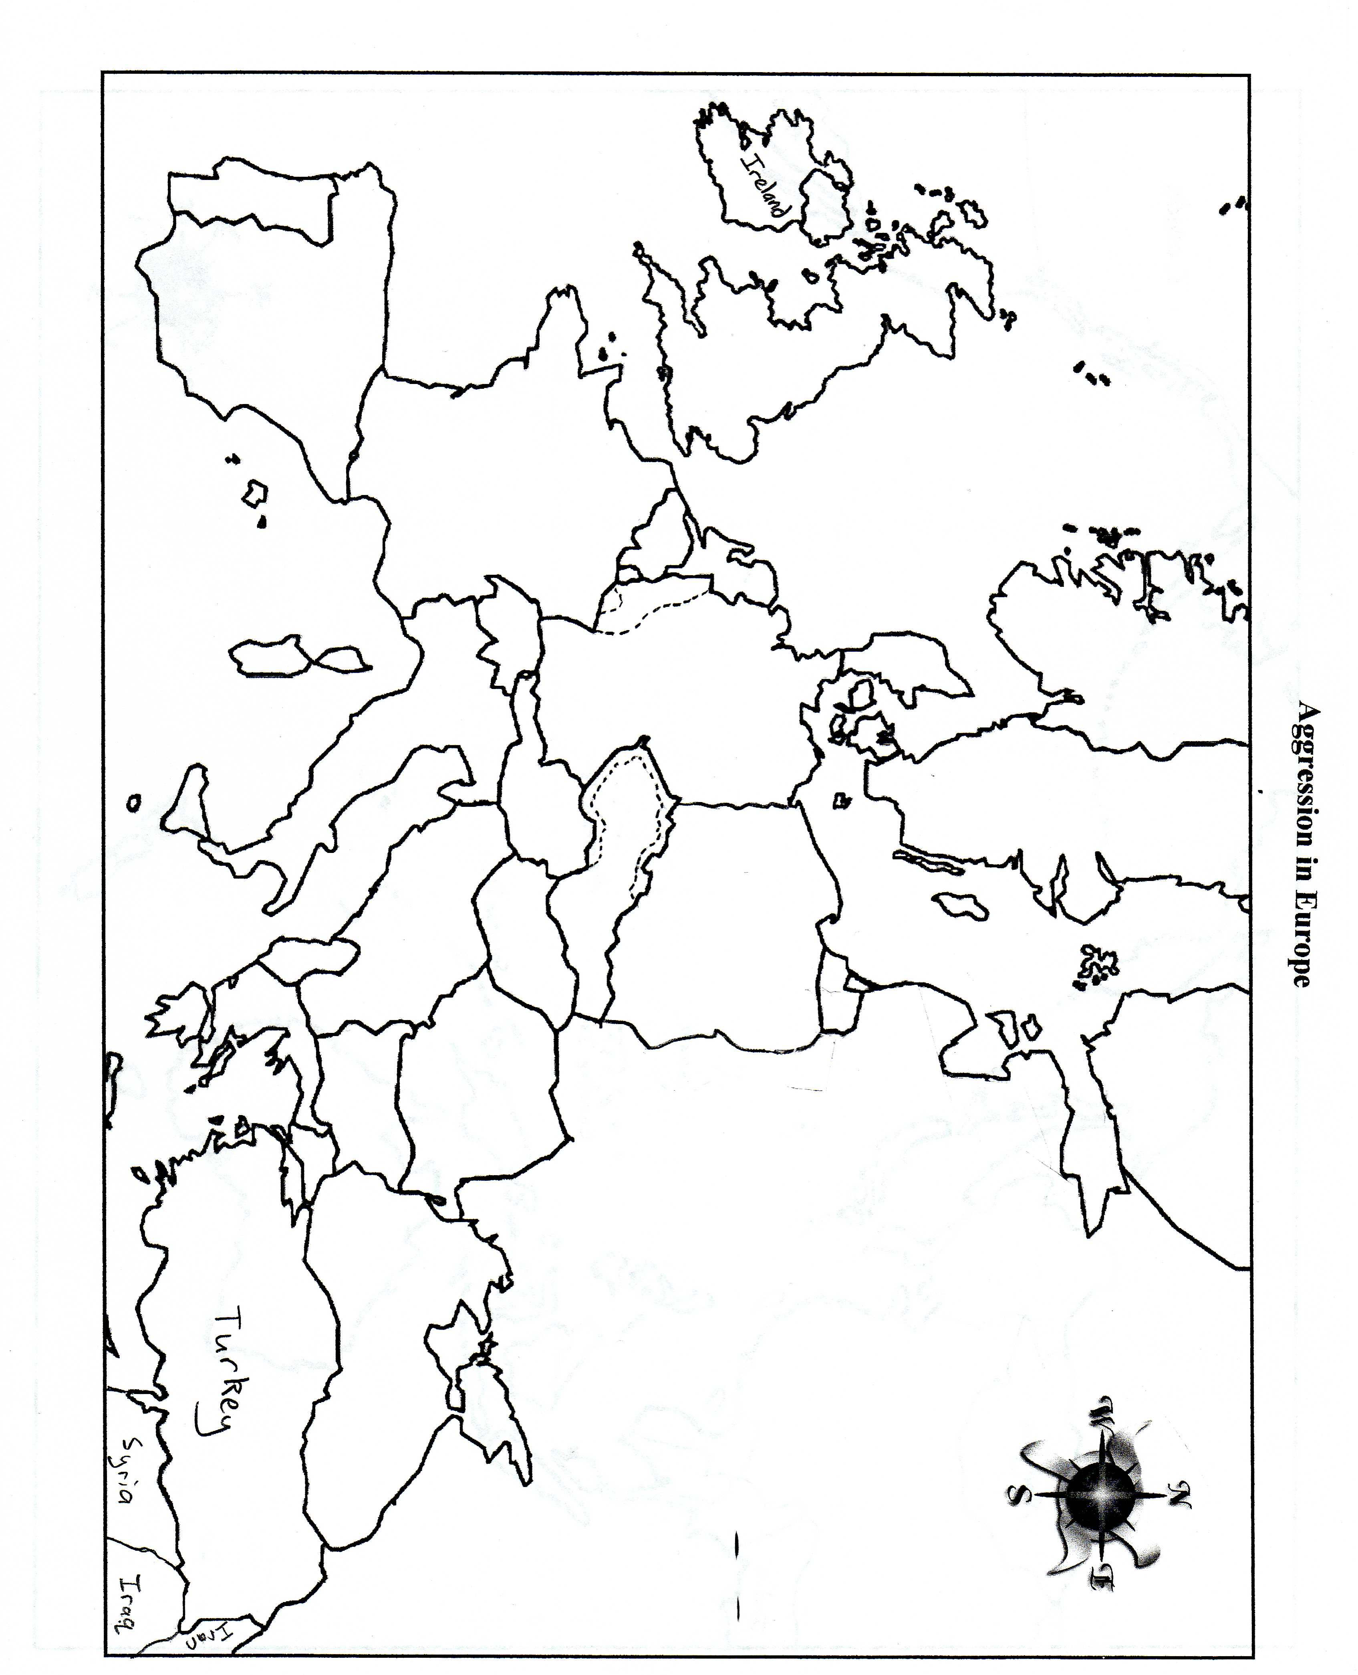

Axis Aggression Maps Name: ____________________
Period.______

Europe pages 922-23, 926

1. Label these water areas on the map and SHADE lightly in Blue.

Atlantic Ocean Mediterranean Sea North Sea
Black Sea Baltic Sea

2. Label the following cities or regions on the map.

London Paris Moscow Berlin Warsaw Rome

3. Label & Shade the members of the Axis Powers in Red.

Germany Italy Hungary Romania Bulgaria Finland

4. Label & Shade in the Neutral countries in Yellow.

Ireland Portugal Spain Turkey Switzerland Sweden

5. Label & Shade the countries or regions occupied by the Axis Powers before Sept. 1939 in Orange.

Sudetenland Rhineland Saar Austria Czechoslovakia Albania

6. Label & Shade the countries occupied by the Axis Powers after Sept. 1939 (to the farthest extent) in Purple.

Netherlands Belgium Denmark France Norway Greece Luxembourg (Lux.) Poland
Yugoslavia

7. Label & Shade in the remaining members of the Allied Powers in Green.

Great Britain Soviet Union

8. Draw the German troop movements into France (1940) and the Soviet Union (1941) using Black.

9. Create a KEY for numbers 3 through 8.

Japan page 933

1. Label these water areas on the map and SHADE them Blue.

Pacific Ocean Indian Ocean South China Sea Coral Sea

2. Label the following cities on the map.

Tokyo Beijing Singapore Hong Kong Pearl Harbor Manila

3. Label & Shade Japan in Red.

4. Label & Shade the countries or regions occupied by Japan before Dec. 7, 1941 in Brown.

French Indochina Manchuria Korea South Sakhalin Island China (Occupied)

5. Label & Shade the countries occupied or attacked by Japan after Dec. 7, 1941 in Orange.

Thailand Burma Malaya Dutch East Indies Hawaiian Islands Philippines

6. Draw a line, in Black, to show the furthest Japanese advances into China.

7. Label & Shade in the remaining members of the Allied Powers in Green.

United States Canada Mexico Soviet Union Mongolia Australia
New Zealand China (Unoccupied) India

8. Create a KEY for numbers 3 through 7.

Axis Aggression Maps Name: ____________________ Period.______

Europe pages 922-23, 926

1. Label these water areas on the map and SHADE lightly in Blue.

Atlantic Ocean Mediterranean Sea North Sea
Black Sea Baltic Sea

2. Label the following cities or regions on the map.

London Paris Moscow Berlin Warsaw Rome

3. Label & Shade the members of the Axis Powers in Red.

Germany Italy Hungary Romania Bulgaria Finland

4. Label & Shade in the Neutral countries in Yellow.

Ireland Portugal Spain Turkey Switzerland Sweden

5. Label & Shade the countries or regions occupied by the Axis Powers before Sept. 1939 in Orange.

Sudetenland Rhineland Saar Austria Czechoslovakia Albania

6. Label & Shade the countries occupied by the Axis Powers after Sept. 1939 (to the farthest extent) in Purple.

Netherlands Belgium Denmark France Norway Greece Luxembourg (Lux.) Poland
Yugoslavia

7. Label & Shade in the remaining members of the Allied Powers in Green.

Great Britain Soviet Union

8. Draw the German troop movements into France (1940) and the Soviet Union (1941) using Black.

9. Create a KEY for numbers 3 through 8.

Japan page 933

1. Label these water areas on the map and SHADE them Blue.

Pacific Ocean Indian Ocean South China Sea Coral Sea

2. Label the following cities on the map.

Tokyo Beijing Singapore Hong Kong Pearl Harbor Manila

3. Label & Shade Japan in Red.

4. Label & Shade the countries or regions occupied by Japan before Dec. 7, 1941 in Brown.

French Indochina Manchuria Korea South Sakhalin Island China (Occupied)

5. Label & Shade the countries occupied or attacked by Japan after Dec. 7, 1941 in Orange.

Thailand Burma Malaya Dutch East Indies Hawaiian Islands Philippines

6. Draw a line, in Black, to show the furthest Japanese advances into China.

7. Label & Shade in the remaining members of the Allied Powers in Green.

United States Canada Mexico Soviet Union Mongolia Australia
New Zealand China (Unoccupied) India

8. Create a KEY for numbers 3 through 7.

Axis Aggression Maps Name: ____________________ Period.______

Europe pages 922-23, 926

1. Label these water areas on the map and SHADE lightly in Blue.

Atlantic Ocean Mediterranean Sea North Sea
Black Sea Baltic Sea

2. Label the following cities or regions on the map.

London Paris Moscow Berlin Warsaw Rome

3. Label & Shade the members of the Axis Powers in Red.

Germany Italy Hungary Romania Bulgaria Finland

4. Label & Shade in the Neutral countries in Yellow.

Ireland Portugal Spain Turkey Switzerland Sweden

5. Label & Shade the countries or regions occupied by the Axis Powers before Sept. 1939 in Orange.

Sudetenland Rhineland Saar Austria Czechoslovakia Albania

6. Label & Shade the countries occupied by the Axis Powers after Sept. 1939 (to the farthest extent) in Purple.

Netherlands Belgium Denmark France Norway Greece Luxembourg (Lux.) Poland
Yugoslavia

7. Label & Shade in the remaining members of the Allied Powers in Green.

Great Britain Soviet Union

8. Draw the German troop movements into France (1940) and the Soviet Union (1941) using Black.

9. Create a KEY for numbers 3 through 8.

Japan page 933

1. Label these water areas on the map and SHADE them Blue.

Pacific Ocean Indian Ocean South China Sea Coral Sea

2. Label the following cities on the map.

Tokyo Beijing Singapore Hong Kong Pearl Harbor Manila

3. Label & Shade Japan in Red.

4. Label & Shade the countries or regions occupied by Japan before Dec. 7, 1941 in Brown.

French Indochina Manchuria Korea South Sakhalin Island China (Occupied)

5. Label & Shade the countries occupied or attacked by Japan after Dec. 7, 1941 in Orange.

Thailand Burma Malaya Dutch East Indies Hawaiian Islands Philippines

6. Draw a line, in Black, to show the furthest Japanese advances into China.

7. Label & Shade in the remaining members of the Allied Powers in Green.

United States Canada Mexico Soviet Union Mongolia Australia
New Zealand China (Unoccupied) India

8. Create a KEY for numbers 3 through 7.

Axis Aggression Maps Name: ____________________ Period.______

Europe pages 922-23, 926

1. Label these water areas on the map and SHADE lightly in Blue.

Atlantic Ocean Mediterranean Sea North Sea
Black Sea Baltic Sea

2. Label the following cities or regions on the map.

London Paris Moscow Berlin Warsaw Rome

3. Label & Shade the members of the Axis Powers in Red.

Germany Italy Hungary Romania Bulgaria Finland

4. Label & Shade in the Neutral countries in Yellow.

Ireland Portugal Spain Turkey Switzerland Sweden

5. Label & Shade the countries or regions occupied by the Axis Powers before Sept. 1939 in Orange.

Sudetenland Rhineland Saar Austria Czechoslovakia Albania

6. Label & Shade the countries occupied by the Axis Powers after Sept. 1939 (to the farthest extent) in Purple.

Netherlands Belgium Denmark France Norway Greece Luxembourg (Lux.) Poland
Yugoslavia

7. Label & Shade in the remaining members of the Allied Powers in Green.

Great Britain Soviet Union

8. Draw the German troop movements into France (1940) and the Soviet Union (1941) using Black.

9. Create a KEY for numbers 3 through 8.

Japan page 933

1. Label these water areas on the map and SHADE them Blue.

Pacific Ocean Indian Ocean South China Sea Coral Sea

2. Label the following cities on the map.

Tokyo Beijing Singapore Hong Kong Pearl Harbor Manila

3. Label & Shade Japan in Red.

4. Label & Shade the countries or regions occupied by Japan before Dec. 7, 1941 in Brown.

French Indochina Manchuria Korea South Sakhalin Island China (Occupied)

5. Label & Shade the countries occupied or attacked by Japan after Dec. 7, 1941 in Orange.

Thailand Burma Malaya Dutch East Indies Hawaiian Islands Philippines

6. Draw a line, in Black, to show the furthest Japanese advances into China.

7. Label & Shade in the remaining members of the Allied Powers in Green.

United States Canada Mexico Soviet Union Mongolia Australia
New Zealand China (Unoccupied) India

8. Create a KEY for numbers 3 through 7.

