World History (Unit 11, #1) Name ______________________________

Date ___________________ Pd ________

**Causes of World War I**

I. From 1914 to 1919, World War I erupted in Europe

A. Overview

1. This “____________________________” was the __________________, most destructive war the world had yet seen

2. WWI was a _________________________________ that altered the course of the 20th century

3. From 1870 to 1914, a number of developments gradually increased _______________________ among the European powers that led to the outbreak of World War I

B. The M.A.I.N. Causes of World War I

1. M _________________________

a. The _______________________________________________________ led to large, advanced militaries in Europe

b. Europeans believed that to be __________________, nations had to have strong ___________________________

c. As a result, an _______________________ began among European nations, especially between Britain & Germany

d. Nations _______________________ military power & kept an _____________ prepared for war (called militarism)

e. Having a strong army increased _____________________________ among citizens

2. A _________________________

a. Growing ____________________ among nations led to the formation of two military _______________________ that threatened to draw European nations into _____________

b. Germany, Italy, & Austria-Hungary made up the _____________________________________________

c. England, France, & Russia formed the ______________________________________________________

3. I _________________________

a. European nations competed fiercely for _____________________________ in Africa & Asia

b. Competition for colonies often pushed Europeans to the _________________________________________

c. This competition increased European rivalry & ________________________

4. N _________________________

a. Rivalries due to militarism & imperialism increased _______________________________ among European powers

b. European rivals tried to maintain a ____________________________________________________________ while also trying to ___________________________ each other

c. While nationalism unified people in the powerful nations, it was ________________ people in weakening empires

d. No region was more tense in the years before World War I than the _______________________________

i. Serbia, Greece, Albania, Bulgaria, & Romania broke from the __________________ Empire to create new nations

ii. __________________ people in ____________________ wanted to unify all Slavs but Austria-Hungary opposed giving up the largely Slavic territories Bosnia & Herzegovina

iii. The Balkans became a “______________________________________________” waiting for a spark to blow up

II. The Outbreak of World War I

A. Assassination of Archduke Franz Ferdinand

1. Serbians vowed to take ___________________ & _____________________________________ from Austria-Hungary

2. On June 28, 1914, the Austro-Hungarian Archduke ____________________________________________________ & his wife were assassinated by a ______________________ terrorist

B. On July 23, Austria-Hungary issued an ______________________________________ to Serbia: turn over conspirators & allow an investigation…*OR…*_____________________________________

1. When Serbia balked at some of the terms, Austria-Hungary _________________________________ on June 28, 1914

2. _______________ had a large population of Slavs & was an ally of Serbia; Russia moved troops to the Austrian border

C. These events set off a chain reaction that __________________________ World War I

D. Allies vs. Central Powers

1. During the war _______________________ & __________________________________ became the Central Powers; They were joined by Bulgaria & the Ottoman Empire

2. The members of the Triple Entente became known as the _____________________________________________ and eventually were joined by…many nations ______________________________________________________________

What were the **M.A.I.N**. Causes of World War I?

What was the spark that lit the dynamite?

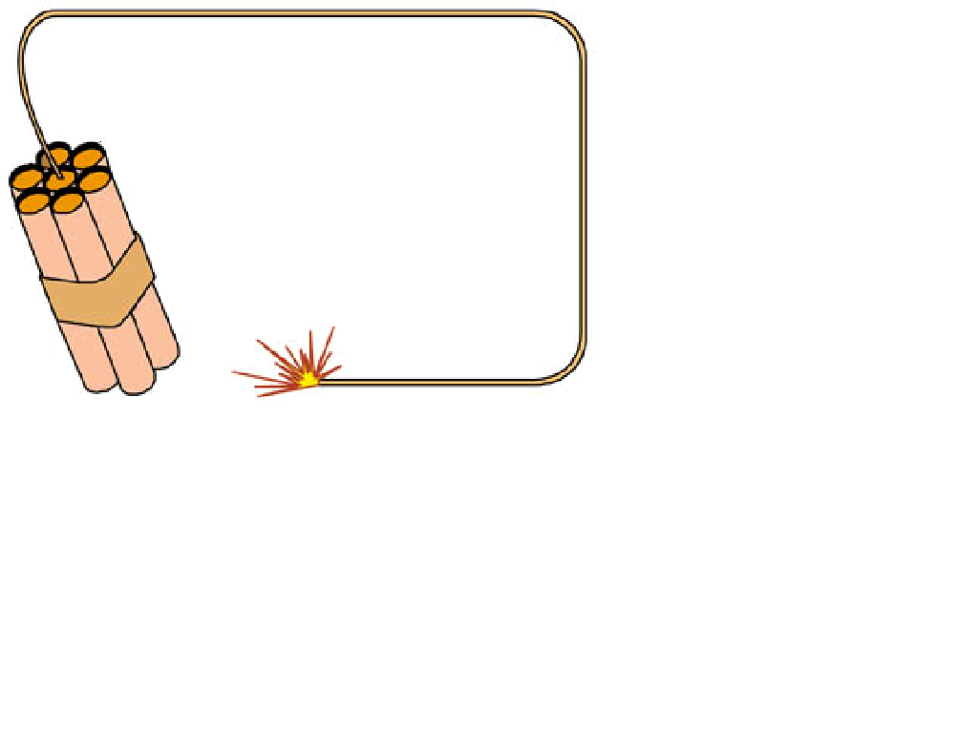



I_________________________________:

Specific Examples:

M_______________________________:

Specific Examples:

N_________________________________:

Specific Examples:

A________________________________:

Specific Examples:

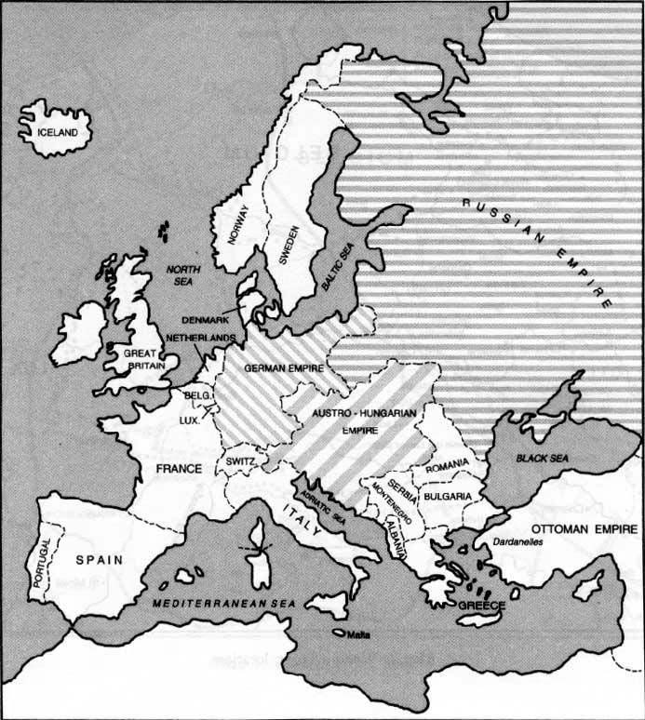

Color code the members of the Triple Alliance

Color code the members of the Triple Entente

Draw a star in the area where the assassination of Archduke Franz Ferdinand took place that began WWI