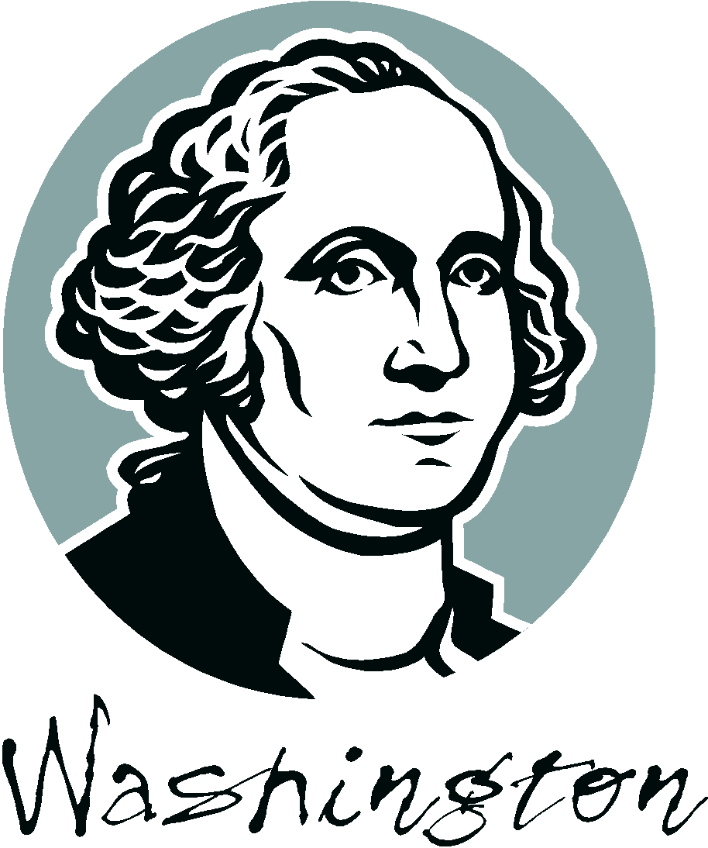
Forming a Cabinet
Guidelines

The purpose of this activity is to gain an understanding of the challenges of forming a new government and the functions of the executive branch.

Directions: Follow the steps below to complete the task put before you!

You have just been chosen as the first president of the United States. It is your job to create your cabinet and the job descriptions that go along with these positions. Good luck on your first challenge as President of the United States!

Step One:
- Create a list of three departments you would like to have working with you.
  - Refer to the list attached for examples of different cabinet positions today
    - Try to be creative with your cabinet positions – things that interest you as the President

Step Two:
- Write out a short, descriptive job description for the heads of these departments.
  - Include:
    - The name and mission (purpose) of each department
    - Tasks this member would perform
    - Qualifications and experience needed
    - Perks (benefits) of this job

Step Three:
- Make a final copy of your job posting on the white sheet provided.
  - It MUST include all of the information from
Step One and Step Two
- Make it creative to make people want to read it and apply for your positions

Step Four:
- Turn in all rough work and your final copy into Mr. Green on Friday, January 13th.

