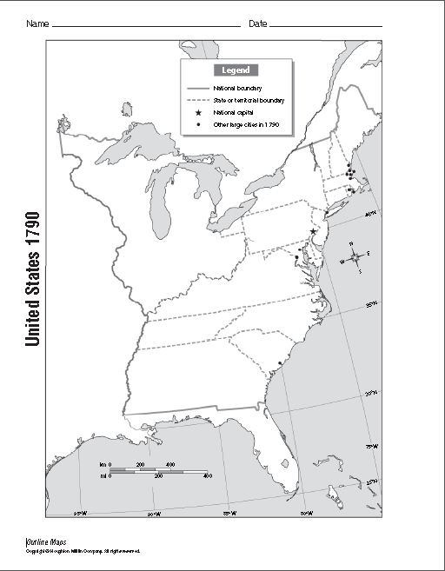
Directions: Using pages 250-251 from the textbook complete the following tasks and answer questions in complete sentences below.

- LABEL the following bodies of water in BLACK.
  - Atlantic Ocean b. Gulf of Mexico

- LABEL the 13 states in BLACK. SHADE the states in PURPLE.
  - Massachusetts b. New Hampshire c. New York d. Rhode Island
e. Connecticut f. Pennsylvania g. New Jersey h. Delaware
i. Maryland j. Virginia k. North Carolina l. South Carolina m. Georgia

3. LABEL the Northwest Territory in BLACK. SHADE all territories on the map in ORANGE.

4. SHADE the areas of the map controlled by other countries in GREEN.

5. What other countries had territory near the United States?

