Colonial Land Claims 1750
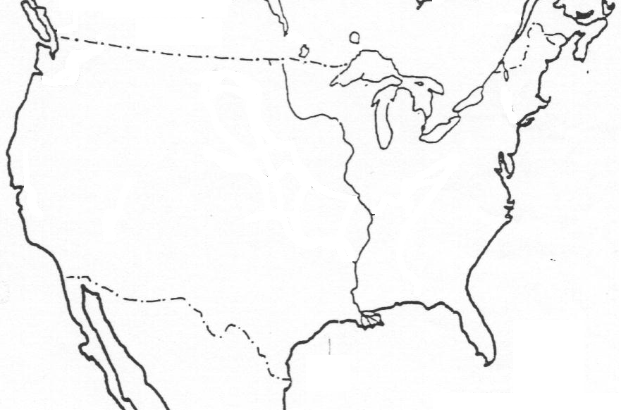
British | French | Spain | Unclaimed Land
Directions:
- LABEL the British Colonies and COLOR them GREEN.
- LABEL New France and COLOR the area PURPLE.
- LABEL New Spain and COLOR the area YELLOW.
- Add each of these colors to the Map Key
- LABEL the following cities on the map:
  - Boston c. Charleston e. Philadelphia
  - New York d. St Augustine f. New Orleans
- LABEL the following bodies of water:
  - Atlantic Ocean b. Pacific Ocean c. Gulf of Mexico d. Mississippi River
- ANSWER the following questions:
  - Which European power claimed the most territory in North America?
  - Which nation’s land claims seem to be the most settled and populated?
  - What effect might these nations’ land claims have on the relations between them?

