Station 1, Part 1: The Election of 1824 and the Corrupt Bargain
Read the passage following passage to help you answer the questions below.
The outcome of the very close election of 1824 surprised political leaders. The winner in the all-important Electoral College was Andrew Jackson, the hero of the War of 1812, with ninety-nine votes. He was followed by John Q. Adams who secured eighty-four votes. William Crawford trailed well behind with just forty-one votes. Although Jackson seemed to have won a narrow victory, receiving 43 percent of the popular vote versus just 30 percent for Adams, he would not be seated as the country's sixth president. Because nobody had received a majority of votes in the electoral college, the House of Representatives had to choose between the top two candidates.

Henry Clay, the speaker of the House of Representatives, now held a decisive position. As a presidential candidate himself in 1824 (he finished fourth in the electoral college), Clay had led some of the strongest attacks against Jackson. Rather than see the nation's top office go to a man he detested, the Kentuckian Clay forged an Ohio Valley-New England coalition that secured the White House for John Quincy Adams. In return Adams named Clay as his secretary of state, a position that had been the stepping-stone to the presidency for the previous four executives.
This arrangement, however, hardly proved beneficial for either Adams or Clay and was denounced immediately as a "CORRUPT BARGAIN" by supporters of Jackson.
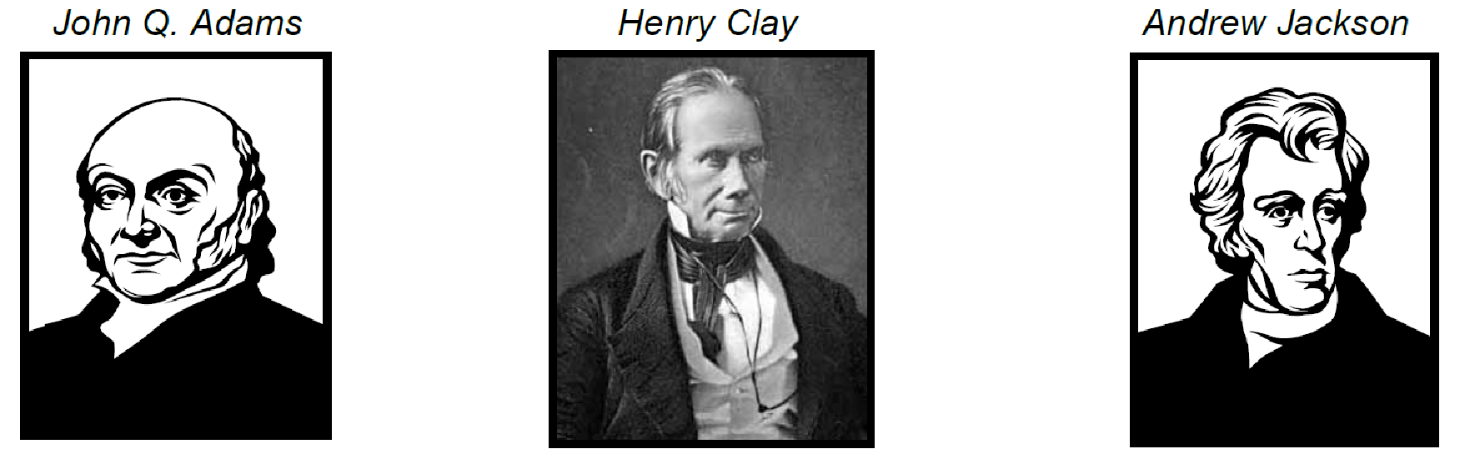
- What role did each of the men above play in this situation?

- Why did this deal become known as the “Corrupt Bargain”?

- Do you agree that this deal was unfair? Explain your position.

Station 1, Part 2: The Election of 1828
Use the maps at this station to answer the following questions.
- How many more popular votes did Jackson receive than Adams in 1828?

- How many more electoral votes did Jackson receive in 1828 than in 1824?

- What region(s) provided Jackson with the most support?
- From the looks of the 1828 map how might the continued expansion west affect national politics and elections?
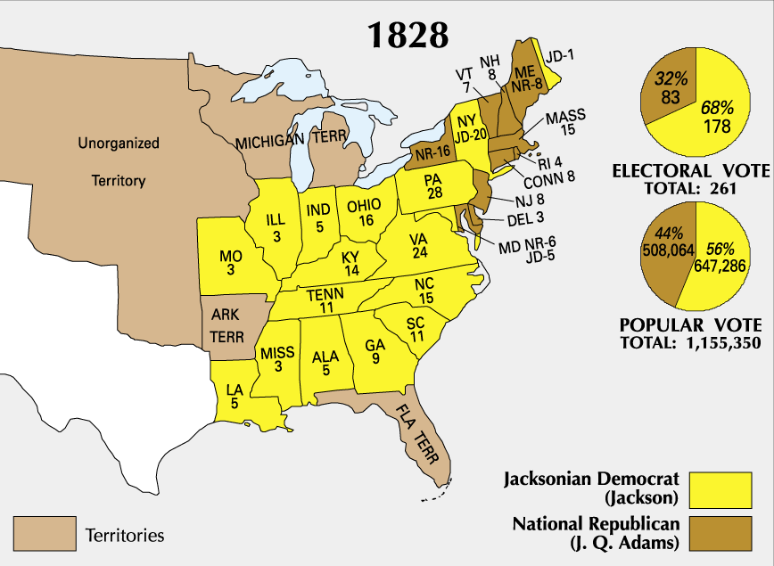
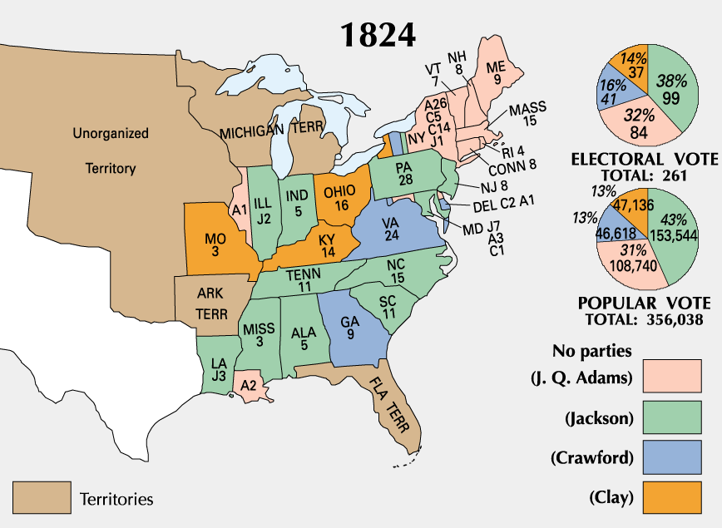
Station 2, Part 1: The Spoils System
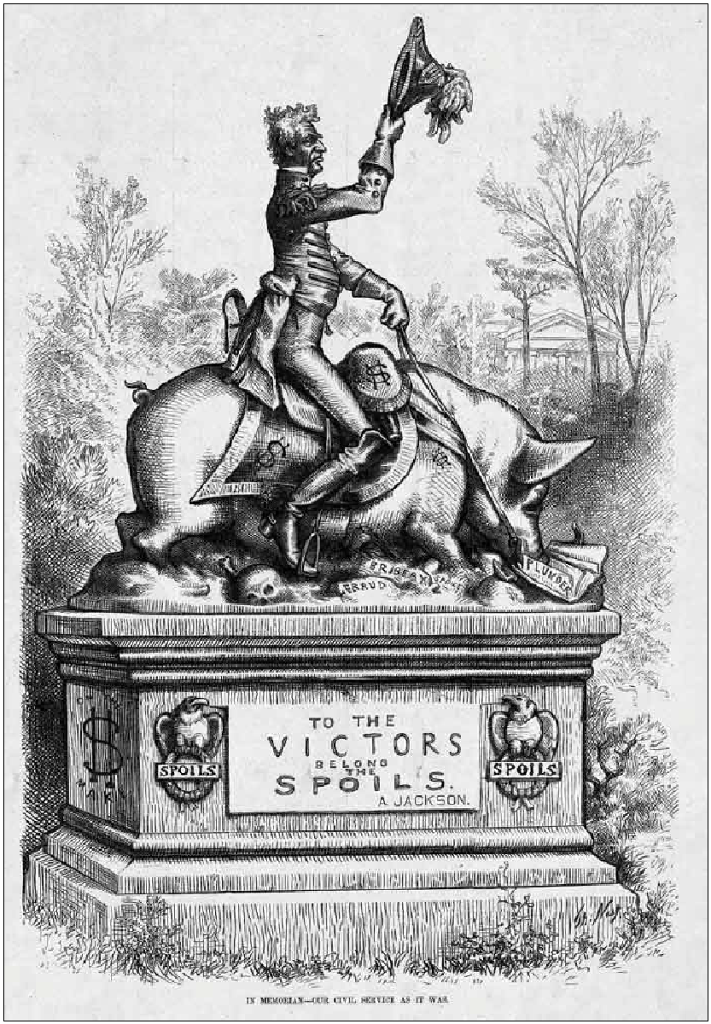
- Read on page 334 then explain what the spoils system was in your own words.

Analyze this political cartoon to help you answer the questions below.
- Why do you think a pig is shown?

- How is this a good visual representation of the Spoils System?

Station 2, Part 2: Spoils System 2
You have just been chosen as president of a new club on campus. You are now responsible for choosing who will serve as a treasurer. The job of treasurer is very important. This person will manage all of the money for the club. They will set up fundraisers and make sure the club spends money in the best way possible. Review the two candidate sheets at this station then answer the questions below.
- List two good qualities of each candidate.

- Which candidate would be best for the club? Explain.

- Be honest, which candidate would you choose? Why?

Candidate 1
- Helped you greatly in your election as president.
- Shares many of the same views and ideas that you do.
- Is very popular in school (and liked by just about everyone).
- Has pretty good grades, except in math.
- Has been your best friend since second grade.
- Bought you lunch last week when you forgot your money at home.

Candidate 2
- Served as the club’s treasurer last year.
- Raised a great deal of money through fundraising and spent it wisely.
- Supported your opponent for election as president.
- Disagrees with some of your plans for the club this year.
- Is insanely good at math.
- Friendly but is very quiet and stays out of the way.
- Only talked to you a couple times.

Station 3: The Tariff of Abominations
At this station are three product sheets. Review them and then answer the questions below.
- Assuming all other features of these phones are the same (like data plans, software, etc.) are the same except for those listed in the ads, which phone would you choose to buy? Why?
- Many people argue that we should buy products “Made in the U.S.A.” whenever possible to help support American jobs. Did that influence your decision on which phone you picked? Why?
- If the HiSense HDX cost $299 and the Sony-Ericsson ECO cost $249 would that change which phone you would pick? Explain.
- Is it a good idea to add a tax to foreign products so more people buy those “Made in the U.S.A.”? Explain.

HiSense HDX
- QUAD 64-Bit Tegra IV Processor*
- 10 hours continuous battery run time
- 2236 x 1440 screen resolution
- Full aluminum casing
- 20 megapixel rear and 8 megapixel front cameras
- Scratch-proof, shatter resistant HYPER glass screen
- Android version 4.4.2
- Made in China
- $99

* Rated “2014 Best on the market” by Engadget.com
Sony-Ericsson ECO 2
- QUALCOMM 32-bit E-Saver Processor
- 14 hours continuous battery time
- Environmentally-Friendly recycled plastic case
- 720 x 480 screen resolution
- 8 Megapixel rear camera
- Android version 4.4.2
- Made in Japan
- $149
Rated “The greenest phone on the market.” by The Wall Street Journal, 2014

Motorola G-1 by Google
- QUAD 64-Bit Tegra IV Processor*
- 9 hours continuous battery run time
- 2000 x 1360 screen resolution
- Full aluminum casing
- 18 megapixel rear and 8 megapixel front cameras
- Scratch resistant flexi-glass screen
- Android version 4.4.2
- Made in the U.S.A.
- $199

* Rated “2014 Best on the market” by Engadget.com

Station 3, Part 2: The Tariff of Abominations

The Tariff: Beginning in 1789, the United States federal government helped America’s young industries by creating a tariff. A tariff is a tax on foreign goods. Many Americans bought British made goods because they were more durable and sold for less. By placing a tax on those British goods it made American products cheaper by comparison so more people would buy from them.
The tariff was raised and 1824, and then raised again in 1828.
It received the nickname: The Tariff of Abominations!
- What does the word “abomination” imply about the tariff? Explain.

Review the following chart to help you answer the remaining questions below.
House of Representatives vote on Tariff of 1828 | For | Against
New England | 16 | 23
Middle-Atlantic States | 57 | 11
West | 17 | 1
South | 3 | 50
Southwest | 12 | 9
Total | 105 | 94

- Many of the nation’s manufacturing businesses were in New England. Why might those states show opposition to the tariff even if it might help their businesses?

- How did states in the South, states that typically supported Jackson, react to the tariff? How can you explain this?

- Why might the Western and Middle-Atlantic states so heavily support the Tariff?

Station 4: The National Bank War
Jackson believed that the main institution holding down the common people and overpowering the rich was the National Bank. As you read Jackson’s explanation for vetoing the bank think about why it may have been seen as a threat to commoners.

- In your experience what are banks used for?

Read the primary source below explaining Andrew Jackson’s veto of the National Bank.

A bank of the United States is in many respects convenient for the Government and useful to the people. However, some of the powers and privileges possessed by the existing bank are unauthorized by the Constitution, subversive of the rights of the States, and dangerous to the liberties of the people….

The present corporate body, denominated the president, directors, and company of the Bank of the United States, will have existed at the time this act is intended to take effect twenty years. It enjoys an exclusive privilege of banking under the authority of the General Government, a monopoly of its favor and support, and, as a necessary consequence, almost a monopoly of the foreign and domestic exchange.

Many of our rich men have not been content with equal protection and equal benefits, but have sought us to make themselves richer by act of Congress. By attempting to gratify their desires we have turned state against state, interest against interest, and man against man, in a fearful commotion which threatens to shake the foundations of our Union. If we cannot make our Government what it ought to be right away, we can at least take a stand against all new grants of monopolies and exclusive privileges, against any prostitution of our Government to the advancement of the few at the expense of the many, and in favor of compromise and gradual reform in our code of laws and system of political economy.

Source: Jackson, A. (1832). President Jackson’s Veto Message Regarding the Bank of the United States. In The Avalon Project.

- What were Jackson’s personal feelings on the National Bank?

- Why was President Jackson vetoing the re-charter of the National Bank?

- Are you convinced that the National Bank was bad? Explain.

Station 4, Part 2: The National Bank War 2
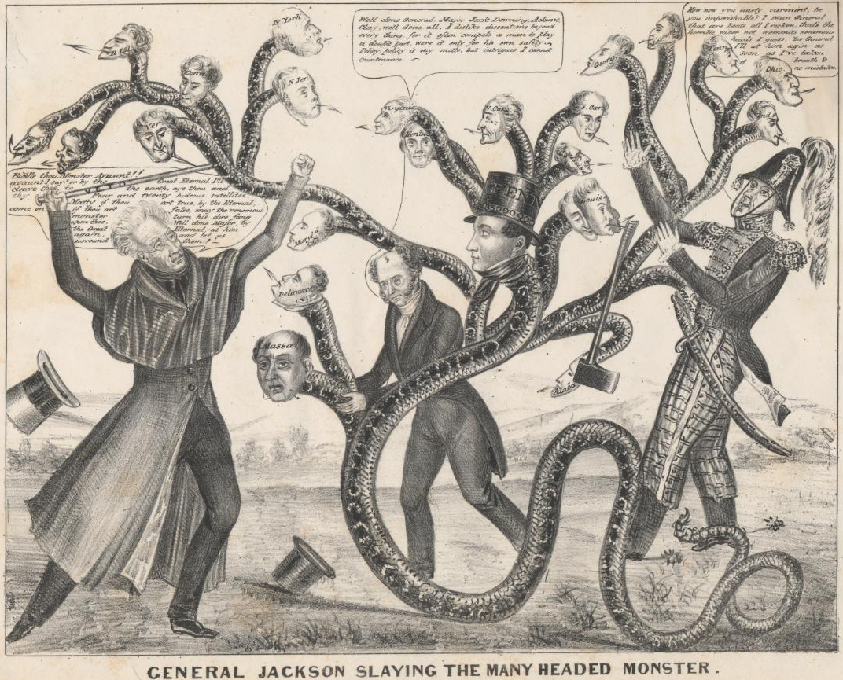
- Why do you think the artist showed the bank be shown as a “many headed monster”?

- Look carefully, what do you see on the heads of the monsters? Why do you think those words are there?

- Do you think the artist supported Jackson or the Bank? Explain.

Station 5: Indian Removal

Jackson wanted to open more land for settlers. When gold was discovered in the Cherokee lands of Georgia this process was accelerated. The Indians were forced out of their land and promised freedom and protection in the west. Examine the images at this station to determine why part of the march became known as the Trail of Tears.

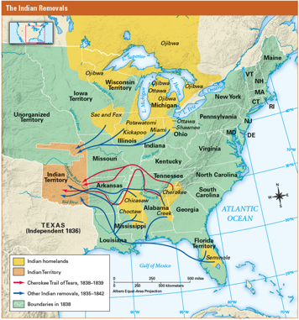

- To where was Jackson attempting to move the Native Americans?

- Jackson argued that this policy was best for both Indians and white settlers in order to keep the peace. Offer a different solution to the problem.
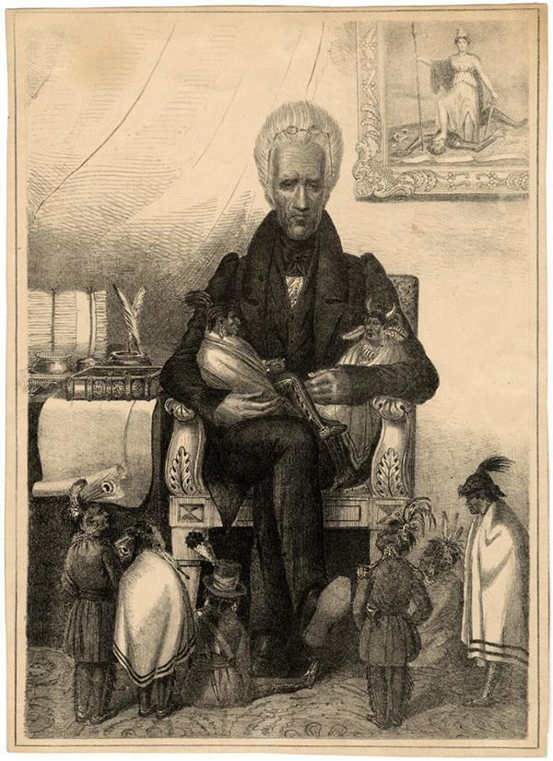
Andrew Jackson, The Great Father

- Describe this picture in detail in at least three sentences.

- What do you think the title of the pictures means?

- This picture is a sarcastic portrayal of Andrew Jackson. What do you think the artist was trying to say about him? Explain.

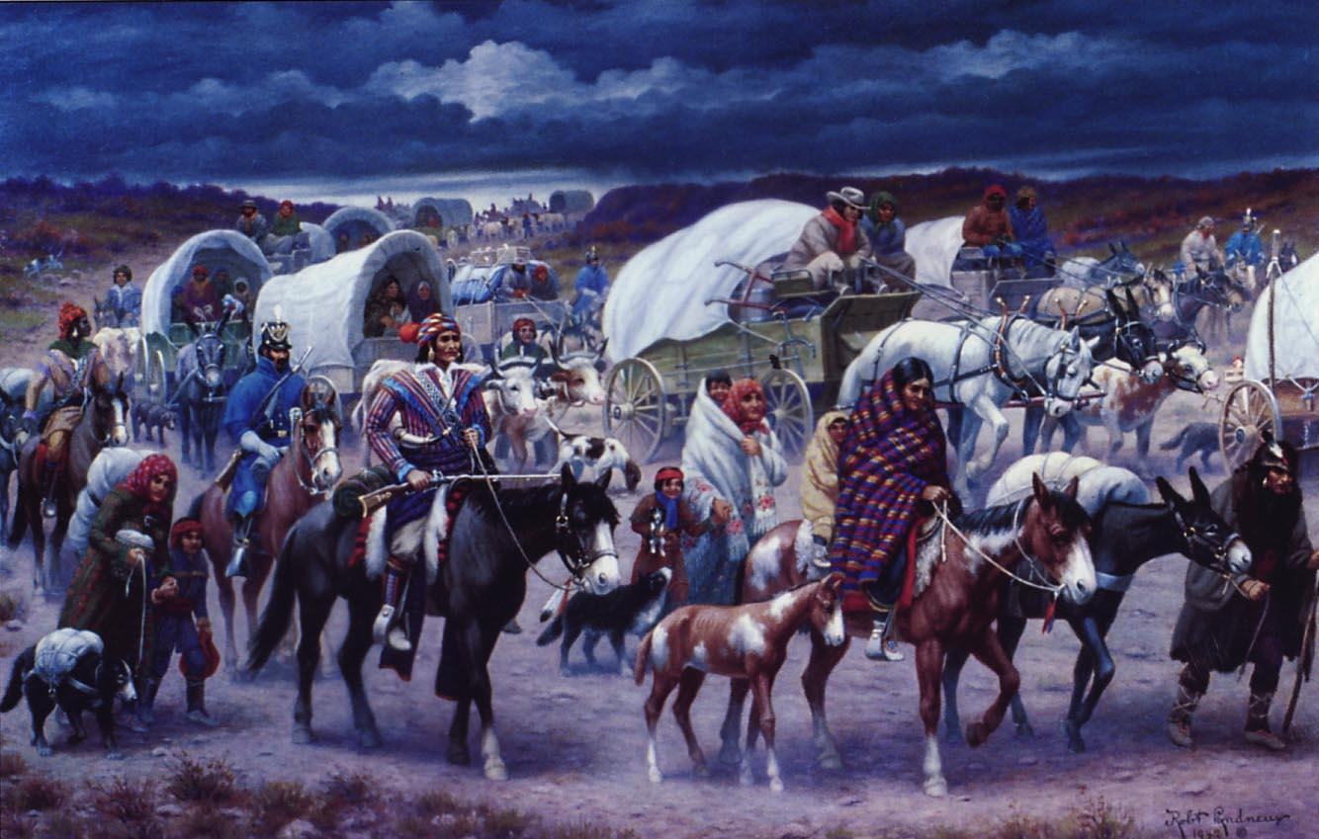
1
2
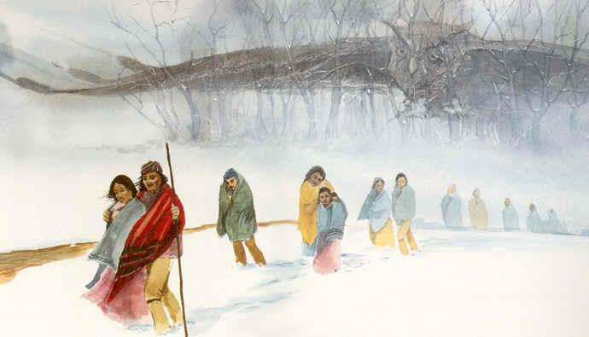
- Compare these two paintings.

- What do you think the owl represents in picture 2?

- How do both of these pictures fit the idea that this was a “trail of tears

Station 6: Nullification and States’ Rights
One major and continuous strain on the union was the issue of trade and tariffs. Heavily dependent upon international trade, the almost entirely agricultural and export-oriented South imported most of its manufactured goods from Europe or obtained them from the North. The North, by contrast, had a growing domestic industrial economy that viewed foreign trade as competition. Trade barriers, especially protective tariffs, were viewed as harmful to the Southern economy, which depended on exports. After the “Tariff of Abominations” passed it got so contentious that South Carolina threatened to nullify the Tariff and even to secede if necessary.
Review the three big head quotes by Daniel Webster, John C. Calhoun and Andrew Jackson then answer the questions below.
- Which of these quotes do you agree with most? Explain.
- Which of these three guys has the coolest hair? Explain.
- Two of these guys were on the same side. Which two? Explain.
- Should states be allowed to ignore laws they find unconstitutional? Explain.
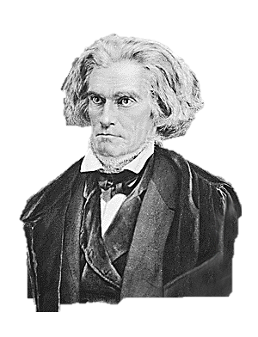
John C. Calhoun
“Because the states formed the national government, state power should be greater than federal power! States should have the right to nullify, or reject, any federal law they find unconstitutional.”
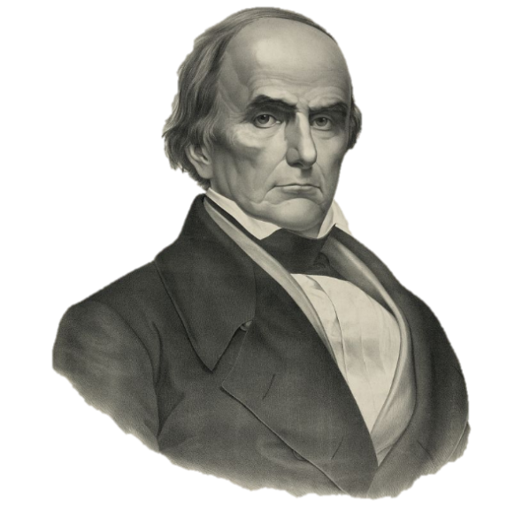

Daniel Webster
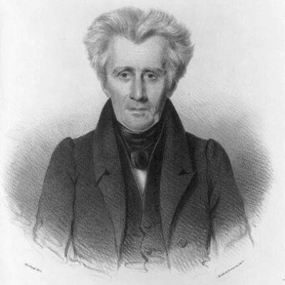
“The United States is one nation, not a pact among independent states. I believe the welfare of the nation should override that of individual states.”

Andrew Jackson
“The power to annul a law of the United States, assumed by one State is incompatible with the existence of the Union, contradicted expressly by the letter of the Constitution, unauthorized by its spirit, inconsistent with every principle on which It was founded, and destructive of the great object for which it was formed.”
Station 6, Part 2: The Force Bill of 1833
- In response to the threat of Nullification Andrew Jackson signed The Force Bill. What does the word “force” make you think this law might have done?

The Force Bill
- Section 1 deals with unlawful obstructions to the collections of tariffs; it allows for the detention of vessels and cargoes to enforce revenue laws, and authorizes the president to use armed forces to protect customs officers and to prevent the unauthorized removal of untaxed vessels and cargo.

- Section 2 expands the jurisdiction of federal courts to cases arising from revenue collections by the U.S. government and allows injured parties in revenue cases to sue in court.

- Section 5 deals with States, or portions within a state, who employ force, or any other unlawful means, to obstruct the execution of U.S. federal law, or interfere with the process of any Federal court. This section authorizes the president to use whatever force necessary to suppress such insurrections, "and to cause the said laws or process to be duly executed".

- Section 6 deals with States who refuse to jail persons imprisoned under Federal law. It authorizes U.S. marshals to jail such persons in "other convenient places, within the limits of said state" and to make provisions for this purpose.

- Section 8 is a sunset clause, stating that the "first and fifth sections of this act, shall be in force until the end of the next session of Congress, and no longer."

APPROVED, March 2, 1833.
- After reading over the text of law, why do you think they named it The Force Bill?

- Do you believe the president should have the power to use the military to force states to follow all federal laws? Explain.

Jackson Stations Answer Sheet
Station 1 Part 1:
1. What role did each of the men above play in this situation?

2. Why did this deal become known as the “Corrupt Bargain”?

3. Do you agree that this deal was unfair? Explain your position.

Station 1 Part 2:
1. How many more popular votes did Jackson receive than Adams in 1828?

2. How many more electoral votes did Jackson receive in 1828 than in 1824?

3. What region(s) provided Jackson with the most support?

4. From the looks of the 1828 map how might the continued expansion west affect national politics and elections?

Station 2 Part 1:
1. Read on page 334 then explain what the spoils system was in your own words.

Analyze this political cartoon to help you answer the questions below.
2. Why do you think a pig is shown?

3. How is this a good visual representation of the Spoils System?

Station 2 Part 2:
1. List two good qualities of each candidate.

2. Which candidate would be best for the club? Explain.

3. Be honest, which candidate would you choose? Why?

Station 3 Part 1:
1. Assuming all other features of these phones are the same (like data plans, software, etc.) are the same except for those listed in the ads, which phone would you choose to buy? Why?

2. Many people argue that we should buy products “Made in the U.S.A.” whenever possible to help support American jobs. Did that influence your decision on which phone you picked? Why?

3. If the HiSense HDX cost $299 and the Sony-Ericsson ECO cost $249 would that change which phone you would pick? Explain.

4. Is it a good idea to add a tax to foreign products so more people buy those “Made in the U.S.A.”? Explain.

Station 3 Part 2:
1. What does the word “abomination” imply about the tariff? Explain.

2. Many of the nation’s manufacturing businesses were in New England. Why might those states show opposition to the tariff even if it might help their businesses?

3. How did states in the South, states that typically supported Jackson, react to the tariff? How can you explain this?

4. Why might the Western and Middle-Atlantic states so heavily support the Tariff?

Station 4 Part 1:
1. In your experience what are banks used for?

2. What were Jackson’s personal feelings on the National Bank?

3. Why was President Jackson vetoing the recharter of the National Bank?

4. Are you convinced that the National Bank was bad? Explain.

Station 4 Part 2:
5. Why do you think the artist showed the bank be shown as a “many headed monster”?

6. Look carefully, what do you see on the heads of the monsters? Why do you think those words are there?

7. Do you think the artist supported Jackson or the Bank? Explain.

Station 5:
1. To where was Jackson attempting to move the Native Americans?

2. Jackson argued that this policy was best for both Indians and white settlers in order to keep the peace. Offer a different solution to the problem.

3. Describe this picture in detail in at least three sentences.

4. What do you think the title of the pictures means?

5. This picture is a sarcastic portrayal of Andrew Jackson. What do you think the artist was trying to say about him? Explain.

6. Compare these two paintings.

7. What do you think the owl represents in picture 2?

8. How do both of these pictures fit the idea that this was a “Trail of Tears?”

Station 6 Part 1:
1. Which of these quotes do you agree with most? Explain.

2. Which of these three guys has the coolest hair? Explain.

3. Two of these guys were on the same side. Which two? Explain.

4. Should states be allowed to ignore laws they find unconstitutional? Explain.

Station 6 Part 2:
5. In response to the threat of Nullification Andrew Jackson signed The Force Bill. What does the word “force” make you think this law might have done?

6. After reading over the text of law, why do you think they named it The Force Bill?

7. Do you believe the president should have the power to use the military to force states to follow all federal laws? Explain.

