The Missouri Compromise 1820
Directions: Use page 318 in the textbook to complete the map and answer the questions.
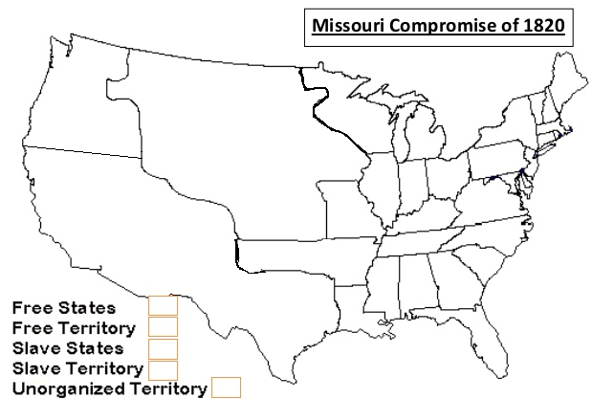
- LABEL the US states in PEN OR PENCIL.
  - Alabama b. Connecticut c. Delaware d. Florida e. Georgia f. Illinois g. Indiana h. Kentucky
i. Louisiana j. Maine k. Massachusetts l. Maryland m. Mississippi n. Missouri o. New Hampshire
p. New Jersey q. New York r. North Carolina s. Ohio t. Pennsylvania u. Rhode Island
v. South Carolina w. Tennessee x. Vermont y. Virginia

2. LABEL the following US territories in PEN OR PENCIL.
- Arkansas Territory b. Michigan Territory c. Unorganized Territory

3. TRACE over the Missouri Compromise line in RED.

4. COLOR the Free States and Territories GREEN, the Slave States YELLOW, the Slave Territories BLUE, and the Unorganized Territory ORANGE.

5. Under the Missouri Compromise was the unorganized territory open or closed to slavery?

6. Do you think the Missouri Compromise was a permanent solution to the question of slavery in new states? Explain.

