The Expanding Nation 1803-1807
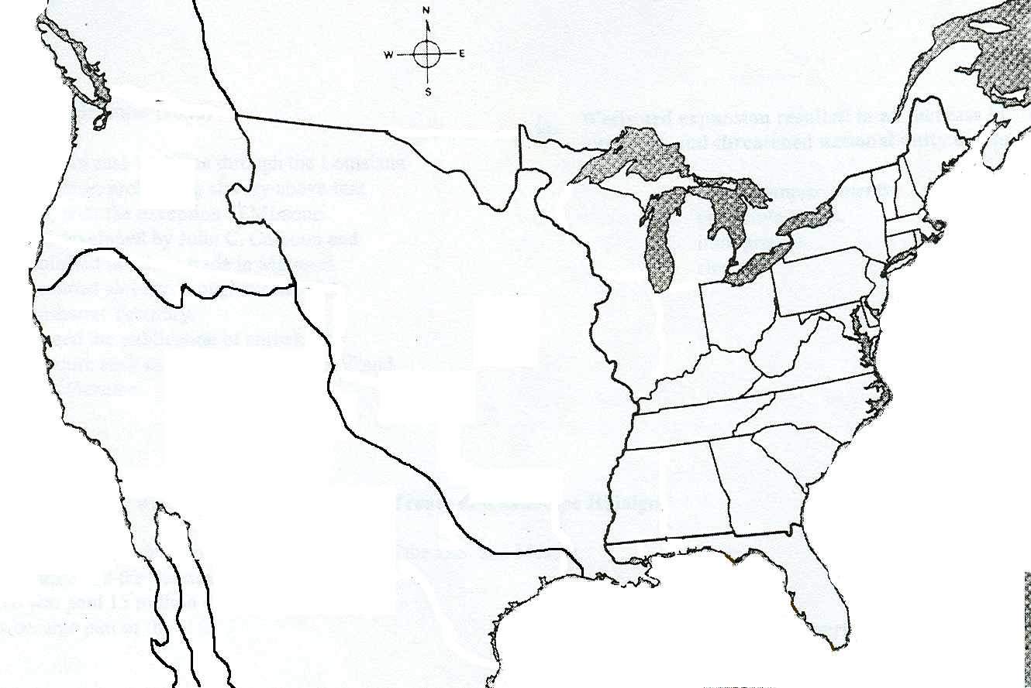
Directions: Use the map on pages 272-273 to complete the following steps.
1. LABEL the following bodies of water in PEN or PENCIL.
  - Atlantic Ocean b. Gulf of Mexico c. Pacific Ocean
2.LABEL the following states in PEN or PENCIL.
a. Maine b. Vermont c. New Hampshire d. Massachusetts e. Rhode Island f. New York
g. Connecticut h. Pennsylvania i. New Jersey k. Maryland l. Delaware m. Ohio n. Georgia
o. Virginia p. Kentucky q. Tennessee r. North Carolina s. South Carolina t. South Carolina
3. LABEL the Mississippi and Indiana Territory in PEN or PENCIL.
4. COLOR the US states and Territory ORANGE.
5. LABEL the Louisiana Purchase in PEN or PENCIL and COLOR it in GREEN.
6. LABEL all the areas that are Spanish Territory in PEN or PENCIL and COLOR them in YELLOW.
7. LABEL all the areas that are British Territory in PEN or PENCIL and COLOR them in PURPLE.
8. DRAW on the map the route taken by Lewis and Clark in BLACK.
9. What territories on the map did Lewis and Clark explore?
10. What were the major geographic obstacles that Lewis and Clark encountered during their journey?
