Name: ____________________ Period: ____________
Directions:Complete each part of the Goal Sheet. Follow the directions that apply to each part). The Goal Sheet is due the day of the Unit 9 Test (____________).

Objectives: WH 6.1, 6.3, 6.4
- Explain how new ideas and theories of the universe altered political thought and affected economic and social conditions.
- Explain how physical geography and natural resources influenced industrialism and changes in the natural environment.
- Analyze the effects of industrialism and urbanization on social and economic reform.

PART I Vocabulary: Write a complete definition for the following terms and concepts. For each starred (*) item create an illustration that represents the term/concept.

The Industrial Revolution
1 Industrial Revolution
2. Enclosure Act
3. Crop Rotation
4. Factors of Production
5. Industrialization
6. Entrepreneur
7. Factory System
8. Assembly line
9. Urbanization
10. Middle Class
11. Adam Smith
12. Capitalism
13. Corporation
14. Laissez Faire
15. Karl Marx
16. Socialism
17. Communism
18. Labor Unions
19. Collective Bargaining
20. Strikes
21. Utilitarianism
22. Thomas Malthus

PART II Essential Questions: On a separate sheet of paper answer the following questions in complete sentences. Explain concepts and use examples when necessary.

- Was a second revolution in agriculture necessary for the Industrial Revolution? Explain.
- What were some of the positives and negatives of industrialization?
- Where did the Industrial Revolution start? Why?

PART III Document Analysis: Read the document below and answer the following questions.

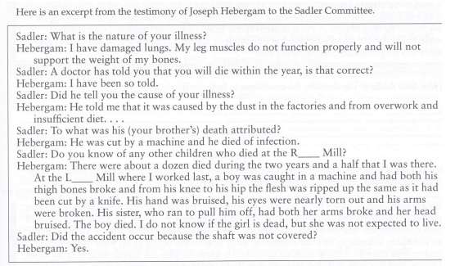
- What is Hebergam’s condition? How did it happen?

2. Describe the working conditions that the children have to deal with?

3. Besides covering the shaft what could be done to make the working conditions safer?

