Directions: Complete each part of the Goal Sheet. Follow the directions that apply to each part. The Goal Sheet is due the day of the Unit 5 Test (____________).

Objective: WH.H.3.2, WH.H.4.1
- Explain how religious and secular struggles for authority impacted the structure of government and society in Europe
- Explain how interest in classical learning and religious reform contributed to increased global interaction
PART I: Vocabulary: Write a complete definition for each term/concept below. In addition for the starred(*) items provide an illustrated example
The Renaissance
1.Renaissance
2. Humanism
3. Secular
4. Perspective*
5. Vernacular
6. Leonardo da Vinci
7. Patron of the Arts*
8. Michelangelo
9. William Shakespeare
10. Johannes Gutenberg
11. Printing Press*
The Reformation
12 Protestant Reformation
13. Martin Luther*
14. Indulgences*
15. Henry VIII
16. Annulment
17. Predestination
18. Presbyterians
19. Anabaptists
20. Catholic Counter Reformation
21. Council of Trent

Part II: On a separate sheet of paper, answer each question completely.
Essential Questions
- Where did the European Renaissance start and why?
- How did the spread of knowledge, and the technologies implemented to do so impact Renaissance society? (Hint: Printing Press)
- What were Martin Luther’s main objections to the Catholic Church? (Practices, teaching, leaders)
- Draw parallels between the impact of the spread of the printed word during the Renaissance and the spread of the computer and internet today.
PART III: Read the Background essay below and answer the questions.
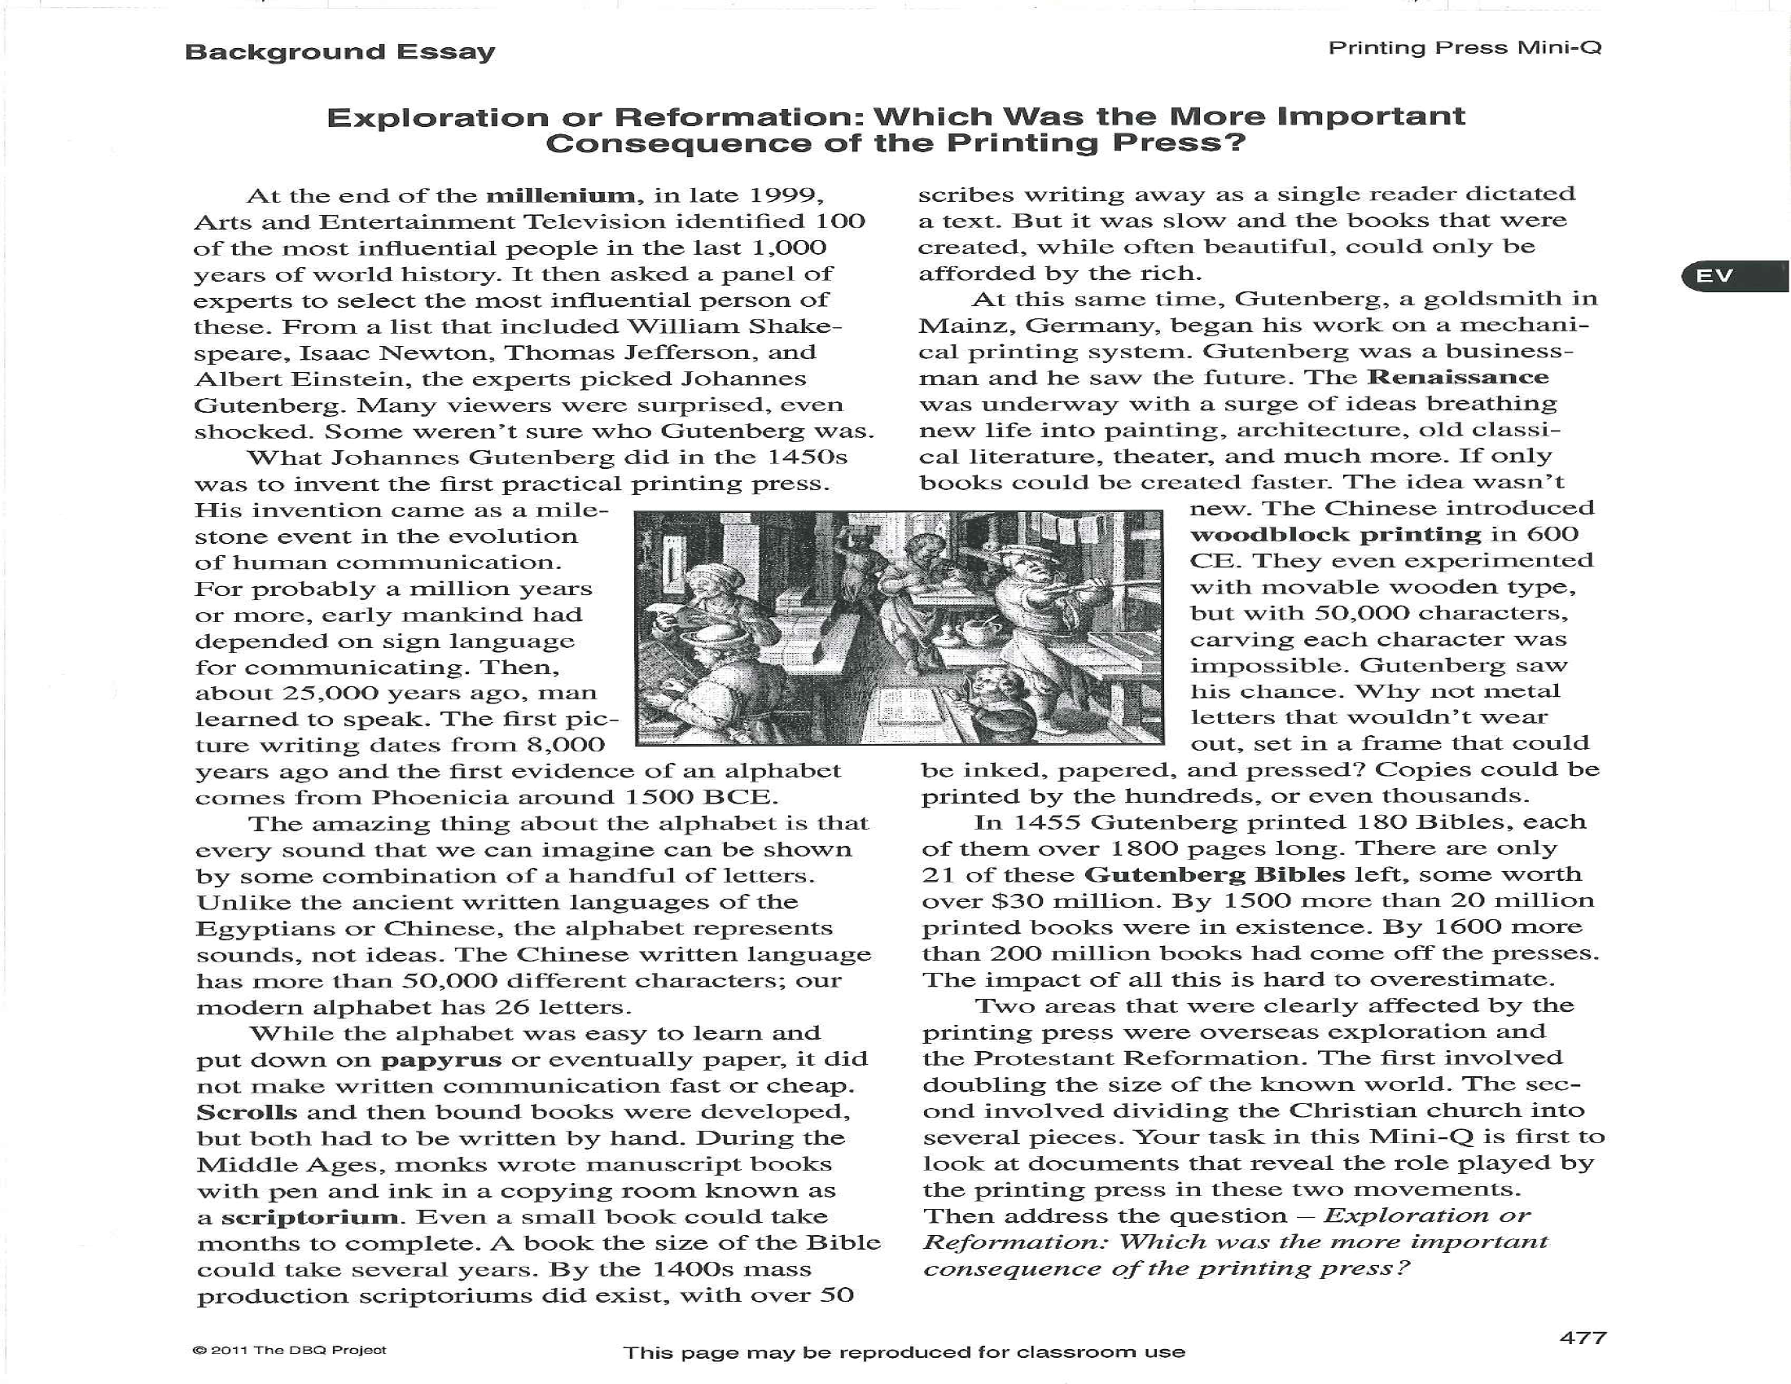
- Who did Arts and Entertainment TV name as the most influential person of the millennium?
- What communication breakthroughs are connected with each of these dates?
  - 25,000 BCE
  - 6,000 BCE
  - 1,500 BCE
  - 600 CE
  - 1,450 CE
- Why is setting type using alphabet letters easier than setting type using chinese characters?
- What effect did the printing press have on the number of books produced and their selling price?

