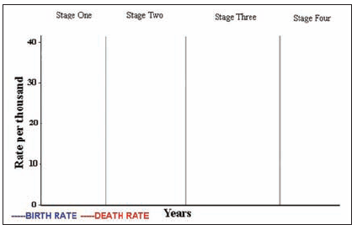
PCHS APHG Name _________________________________
Unit 3: Population
Demographic Transition Model (DTM)

 | Stage One | Stage Two | Stage Three | Stage Four
Birth Rate

Death Rate

What’s going on? Why?

Total Population

Examples

PCHS APHG Name _________________________________
Unit 3: Population
Population Pyramids
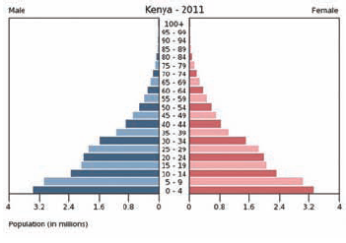
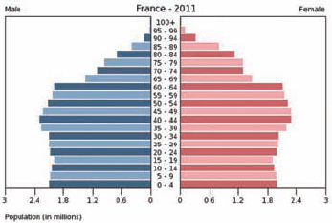
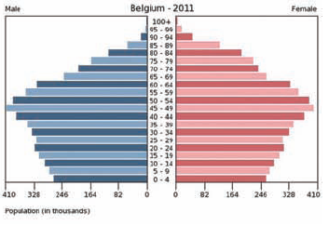

India Case Study:

India 2000 | India 2025 | India 2050
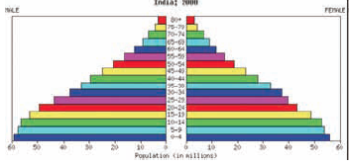 | 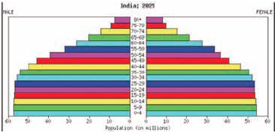 | 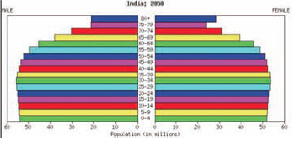

Population Pyramid Practice: Kuby Ch. 5, Activity 1:

A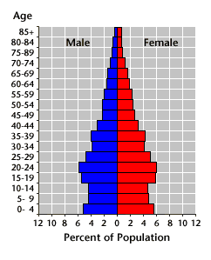 | B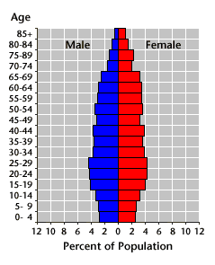 | C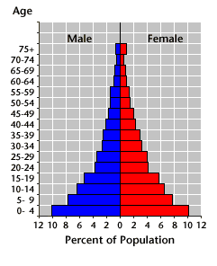
D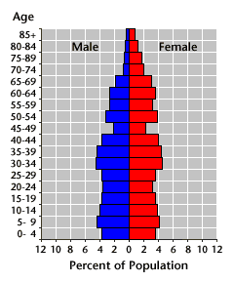 | E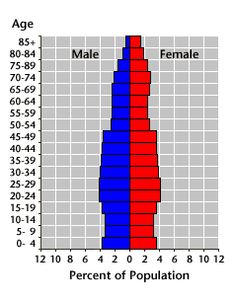 | F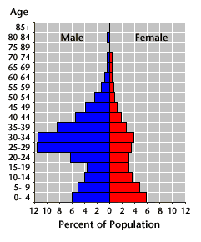

________________________ A country which has recently undergone a shift from high to low fertility

________________________ A country with many temporary immigrant workers

________________________ A country with a declining population

________________________ A country with rapid population growth

________________________ A country which shows the demographic effects of World War II

________________________ A country with almost zero population growth

PING Population Pyramids:
- Create population pyramids for your PING and explain their shapes.
- Use these websites to create the pyramids then sketch the shape in the boxes below. Then make a hypothesis about the DTM stage and possible explanations for each.

Online Population Pyramid Generators:
- http://populationpyramid.net/
- http://www.census.gov/population/international/data/idb/informationGateway.php (Choose “Population Pyramids” from the “Select Report” menu)

PING Country: __________________________________

Date | Pyramid Shape (sketch) | DTM Stage and Explanation of Shape (Your hypothesis)
1970

2000

2025

2050

Do you have extra time? This is interesting:
http://developers.arcgis.com/javascript/samples/geoenrichment_infographic/
Click anywhere on the map of the United States to see a population pyramid for a 1-mile radius. What does Charlottesville’s look like?

